NXP LPC213X
Advanced Development Board

User Manual

CONTENTS

1. Introduction
Technical/Customer Support 3
Package contains 4
Board Introduction 5
2. Connectors and Jumper Details 9
3. Power Supply Block 12
4. ZIF Socket Details 12
5. Flash programmers 13
6. Onboard Peripheral/Interface Details 17
6.1 - Point LEDs 18
6.2 – Digital Inputs Toggle Switches 21
6.3 - LCD 2x16 in 8-bit mode 23
6.4 - GLCD 128x64 27
6.5 - UART RS-232 Communication 32
6.6 - Real Time Clock 36
6.7 – I2C EEPROM 43
6.8 - 7 Segment LED 48
6.9 - Interrupts 52
6.10 - DS1820 (Digital Thermometer) 53
6.11 - Matrix keypad 57
6.12 - Stepper Motor Driver 62
6.13 - Relay Driver 64
6.14 – SPI DAC 66
6.15 – RS-485 68
6.16 – PS/2 70
6.17 – Ethernet 73
6.18 – ADC On-Chip 76
6.19 – CAN 79
7. Board Layout 81
9. Easy Programming Steps 82

Technical or Customer Support

E-mail questions to support@pantechsolutions.net

Send questions by mail to
Pantech Solutions Pvt Ltd.,
#3/2, Ramachandran Street,
Off: North Usman Road,
T.Nagar
Chennai – 600 017.
Tamilnadu
India

Phone : +91-44-4260 6470
Fax : +91-44-4260 6480
Website : www.pantechsolutions.net

Packages

- ARM ADB Development module
- Serial Port Cable.
- 10-pin FRC Cables
- Printed User Manual
- CD contains
  - Software (Programmers, IDE)
  - Example Programs
  - User Manual

1. Introduction

ARM Advanced Development Board is proposed to smooth the progress of developing and debugging of various designs encompassing of High speed 32-bit Microcontrollers from NXP. The board supports NXP’s LPC213x family devices with various memory and peripheral options. The board is comprised of a application board and a mother board. The mother board holds the NXP’s LPC213x series microcontrollers.
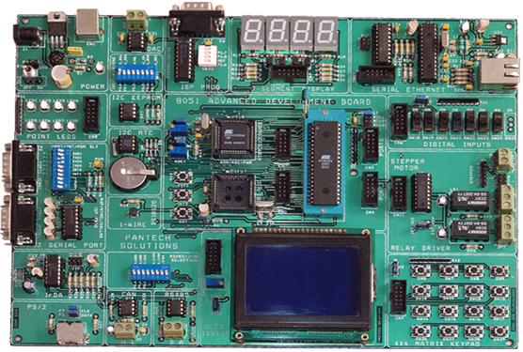

It integrates on board two UARTs, LEDs, keypads, an ADC input and LCD Display to create a stand-alone versatile test platform. A 20-pin JTAG interface is also provided on this board to support high-speed download, in-circuit debugging and flash programming. User can easily engage in development in this platform, or use it as reference to application development. Many real world applications can be tested on the board. RS485, RTC, DAC, Digital Temperature controllers, Motor drivers, Memory interfacing, counters, timers...

General Block Diagram




LPC213X

2x PS/2

16-Channel
10-bit ADC

SPI – DAC

EEPROM

128x64 GLCD
2x16 LCD

Real Time Clock

CAN 2.0

JTAG

8 Nos.
Point LED

Two
Ext Interrupts

PWM

2 X UART

Ethernet

9V AC/DC Input
5V Regulator

Stepper Motor/
Relay Outputs

4x4 Matrix
Keypad

1-Wire
Temp Sensor

RS485

Serial
ISP Programmer

3.3V Regulator
Ethernet supply

4 Nos. Seven
Segment Display

8 Nos.
Digital Inputs

Specifications

- MCU: LPC2138 16/32 bit ARM7TDMI-s™ with 512k Bytes Program Flash, 32k bytes Ram, RTC, 8x 10 bit ADC 2.44 us, 2x UARTS, I2C, SPI, 2x 32bit Timers, 8x CCR, 6x PWM, WDT, 5V Tolerant I/O, up to 60MHZ operation
- Standard JTAG connector with arm 2x10 pin layout for programming and debugging with ARM-JTAG.

- External Peripheral Modules

  - 128X64 GLCD Interface
  - 2x16 Character LCD with Contrast adjust
  - 10Mbps Ethernet Interface.
  - 4-Nos. of common anode seven segment display.
  - 8-Nos. General purpose Point LEDs.
  - 8-Nos. of Slide switches (Digital Inputs).
  - 4x4 Matrix keypad.
  - Stepper Motor Driver Output.
  - Two Nos. of 5V Relay with termination.
  - Two PS/2 keyboard Interface.
- Communication Protocols
  - CAN (2.0A and 2.0B) (Bosch)
  - I2C Two Wire Interface (NXP)
  - SPI (Motorola)
  - 1-wire Technology (Maxim-Dallas)
  - Two Full Duplex UART (EIA)
  - RS485 (EIA)
- Other Features
  - Digital to Analog Converter.
  - Real Time Clock with Battery Backup.
  - Serial EEPROM memory.
  - Digital Temperature sensor
  - RS485 serial communication through long distance(>200m)

  - On board voltage regulator (3.3V - 800mA, 5V – 1000mA).
  - External USB power supply (5V,500mA).
  - On-board FLASH ISP Programming for Philips microcontrollers.
  - Two pushbuttons for Interrupts study.
  - Power ON status Indication LED.
  - User selectable jumpers.
  - Li-ion 3V Battery Holder
  - 12 MHz crystal on socket, allow easy communication setup (4x PLL = 48 MHz CPU clock)
  - 32.768Khz crystal and RTC backup battery connector
  - Extension headers for all uc ports.

2. Connectors and Jumper Details

JP7 - 10PIN Box Header (P0.0 - P0.7)

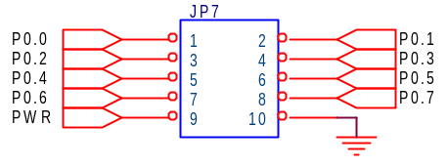
JP11 - 10PIN Box Header (P0.8 - P0.15)

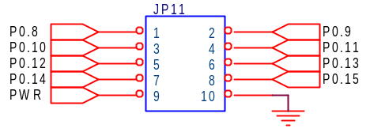
JP13 - 10PIN Box Header (P0.16 - P0.23)

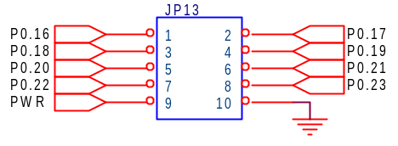
JP14 - 10PIN Box Header (P0.25 - P0.31)

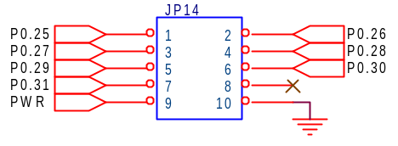
JP8 - 10PIN Box Header (P1.16 – P1.23)

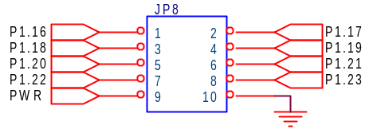

JP12 - 10PIN Box Header (P1.24 – P1.31

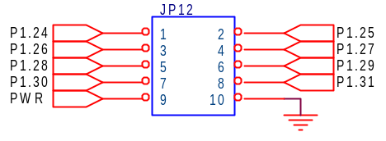

JP5 – 3pin Header (Power select connectors)

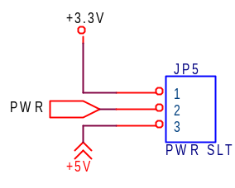

Jumper for Enable Power to MCU
- Short Pin 1&2 of JP5(+3.3V, to All Port I/O connector)
- Short Pin 2&3 of JP5(+5V, to All Port I/O connector)

3. Power Supply

The external power can be AC or DC, with a voltage between (9V/12V,1A output) at 230V AC input. The ARM board produces +5V using an LM7805 voltage regulator, which provides supply to the peripherals. +LM1117 Fixed 3.3V positive regulator used for processor & processor related peripherals. USB socket meant for power supply only, user can select either USB or Ext power supply through JP1. Separate On/Off Switch (SW1) for controlling power to the board.
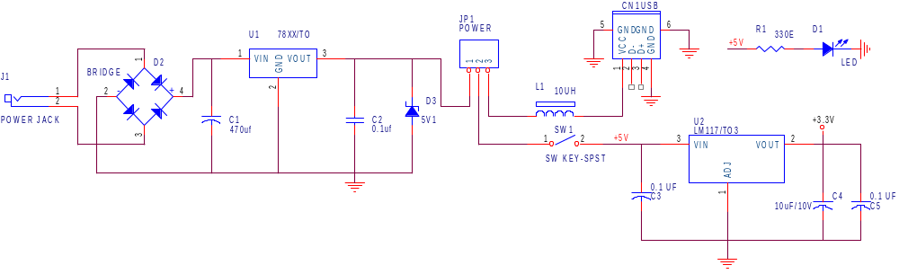

4. MCU Sockets

- The ARM Mother board is delivered with NXP’s LPC2138 64-pin PQFP package, It’s on-board JTAG connector provided to debug & download code to the processor.

5. Flash Programming Utility
1. NXP (Philips)

NXP Semiconductors produce a range of Microcontrollers that feature both on-chip Flash memory and the ability to be reprogrammed using In-System Programming technology.

Programming Mode
SW2 (pin 5 & 6) make it ‘on’ (P1.20 & P1.26 make low), program mode NXP (Philips) microcontrollers.

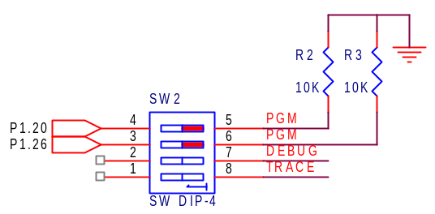

Execution Mode
SW4 (Pin 5 & 6) make it ‘off’ , execution mode NXP (Philips) microcontrollers.

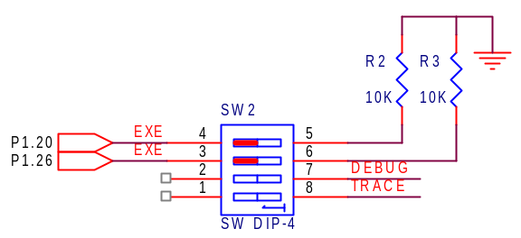

6. On-board Peripherals

The Development board comes with many interfacing options
- 8-Nos. of Point LED’s (Digital Outputs).
- 8-Nos. of Toggle switches (Digital Inputs).
- 2 Lines X 16 Character LCD Display.
- 128X64 GLCD Interface
- On-chip Real Time Clock with battery backup.
- 4 Nos. of Seven-segment display.
- Digital Temperature Sensor
- 4 X 4 Matrix keypad.
- Relay / Stepper Motor driver circuit.
  - SPI - Digital to Analog Converter.
  - Serial EEPROM memory.
  - RS485 serial communication through long distance(>200m)
  - Two UART for serial port communication through PC.
  - Two Nos. of PS/2 Interface.
  - 10Mbps Ethernet Interface.

6.1 - Light Emitting Diodes

- Light Emitting Diodes (LEDs) are the most commonly used components, usually for displaying pin’s digital states.

- The ARM AD Board have 8 nos., of Point LED, user can interface the point LEDs with any port.

- Connector CN4 for LED connector, when High Level goes to the pin LED glows.

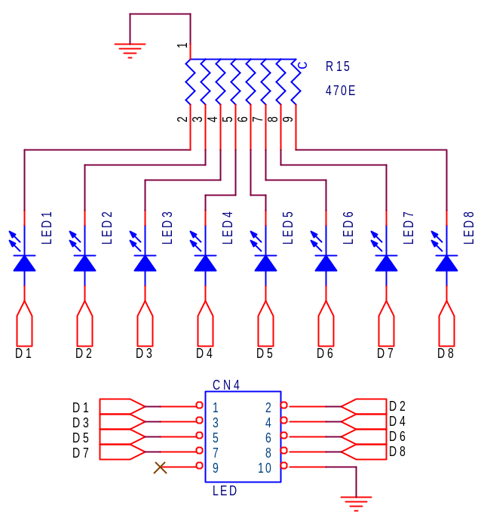

6.2 – Digital Inputs Toggle Switch

- This is another simple interface, 8-Nos. of toggle switch, mainly used to give an input to the port lines, and for some control applications also.

- User can change the level of digital inputs whatever they want, either high or low by simply selecting the jumper J3. The switches are connected to +5V, in order to detect a switch state, pull-up or pull-down resistors should be used.

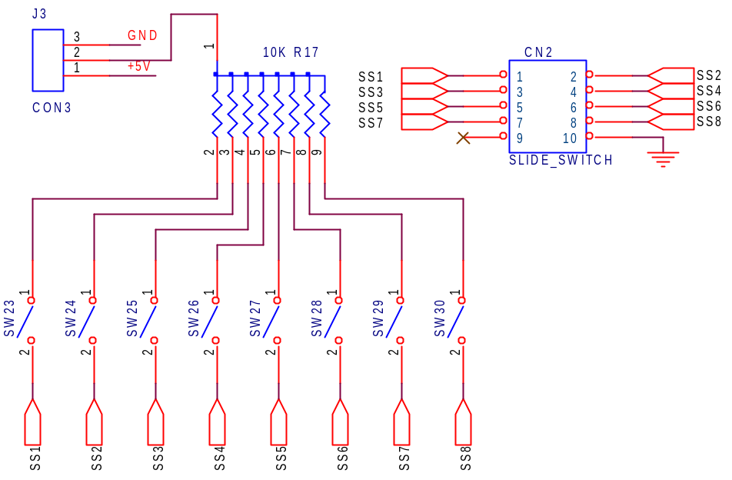

6.3 - LCD 2x16 IN 8-BIT MODE

- When using a LCD, the connector CN6 connects the LCD to Microcontroller port lines. User can use LCD Data lines to Port P0[0-7], P0[16-24], P0[25-32] and P1[16-31], not P0[8-15], because P0 lines P0.12(RS), P0.13(R/W) and P0.14 (Enable) connected by default. The LCD’s contrast can be adjusted by varying the trimpot (R18).

- Before using LCD insert the shunt or shorting link of jumper J5 mentioned to CHAR legend mark.

- Place 2x16 Character LCD to proper place, mentioned legend in PCB.
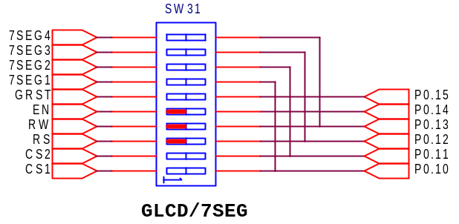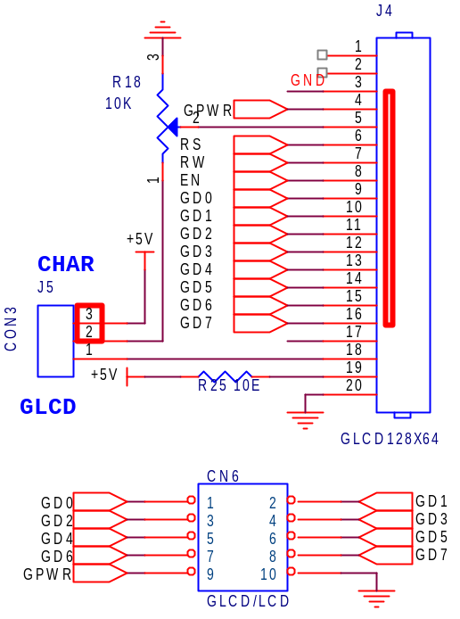

Note : SW31 make switch positions above for 2x16 LCD

6.4 - 128X64 Graphic LCD
- When using a Graphic LCD, the connector CN6 connects the LCD to Microcontroller port lines. User can use GLCD Data lines to Port P0[0-7], P0[16-24], P0[25-32] AND P1[16-31], not P0[8-15], because P0 lines P0.10(CS1), P0.11(CS2), P0.12(RS), P0.13(R/W) and P0.14 (Enable) connected by default. The LCD’s contrast can be adjusted by varying the trimpot(R18).

- Before using LCD insert the shunt or shorting link of jumper J5 mentioned to GLCD legend mark. Adjust(R18) for GLCD Negative Voltage

- Place GLCD to proper place, mentioned in PCB.

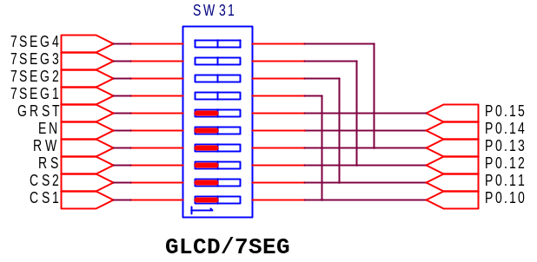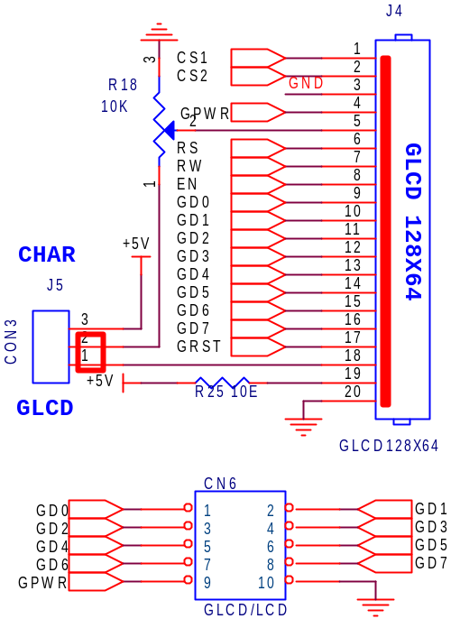

Note : SW31 make switch positions above for 2x16 LCD

6.5 - RS-232 Communication

- RS-232 communication enables point-to-point data transfer. It is commonly used in data acquisition applications, for the transfer of data between the microcontroller and a PC.

- The voltage levels of a microcontroller and PC are not directly compatible with those of RS-232, a level transition buffer such as MAX3232 be used.

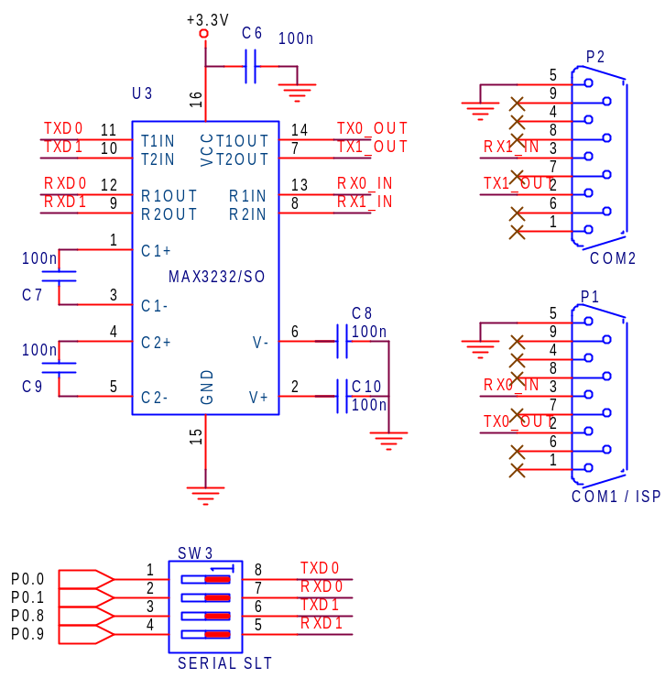

: Note : Make switch positions like above, UART0(P1) & UART1(P2)

Output
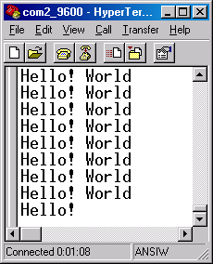

6.6 - Real Time Clock

The Real Time Clock (RTC) is a set of counters for measuring time when system power is on, and optionally when it is off. It uses little power in Power-down mode. On the LPC2131/2/4/6/8, the RTC can be clocked by a separate 32.768 KHz oscillator, or by a programmable prescale divider based on the VPB clock. Also, the RTC is powered by its own power supply pin, VBAT, which can be connected to a battery or to the same 3.3 V supply used by the rest of the device.

Features
• Measures the passage of time to maintain a calendar and clock.
• Ultra Low Power design to support battery powered systems.
• Provides Seconds, Minutes, Hours, Day of Month, Month, Year, Day of Week, and Day of Year.
• Dedicated 32 kHz oscillator or programmable prescaler from VPB clock.
• Dedicated power supply pin can be connected to a battery or to the main 3.3 V.

6.7 – Serial EEPROM

The AT24C01A/02/04/08/16 provides 1024/2048/4096/8192/16384 bits of serial electrically erasable and programmable read-only memory (EEPROM) organized as 128/256/512/1024/2048 words of 8 bits each. The device is optimized for use in many industrial and commercial applications where low-power and low-voltage operation are essential. The AT24C01A/02/04/08/16 is available in space-saving 8-pin PDIP.

Features of AT24Cxx:
- Internally Organized 128 x 8 (1K), 256 x 8 (2K), 512 x 8 (4K)
• 2-wire Serial Interface
• Schmitt Trigger, Filtered Inputs for Noise Suppression
• Bi-directional Data Transfer Protocol
• 100 kHz (1.8V, 2.5V, 2.7V) and 400 kHz (5V) Compatibility
• Write Protect Pin for Hardware Data Protection
• 8-byte Page (1K, 2K), 16-byte Page (4K, 8K, 16K) Write Modes
• Partial Page Writes are Allowed
• Self-timed Write Cycle (10 ms max)
• High-reliability
– Endurance: 1 Million Write Cycles
  - Data Retention: 100 Years

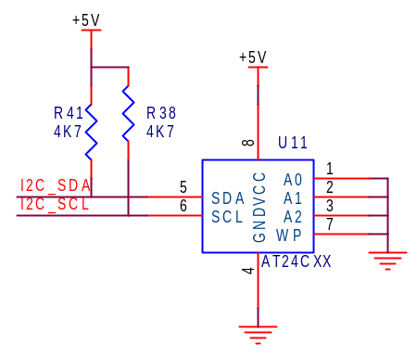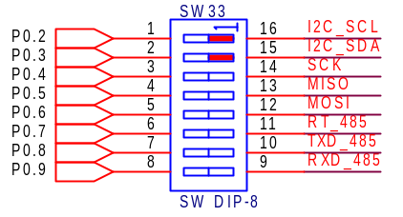

OUTPUT

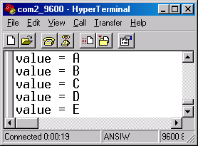

6.8 - Seven Segment Display

In Embedded module 4 nos. of common anode seven segment displays are used. The segment lines of seven segments LED is being terminated at connector CN5. The digit select lines are connected to the port pins of LPC2138 by using BC547. All the common anode displays consume very small amount of current. User can use segment lines at any port P0, in all, not (P0.8-P0.15), P1, by default digit select lines connected to Port P0 of PinP0.10 to P0.13.
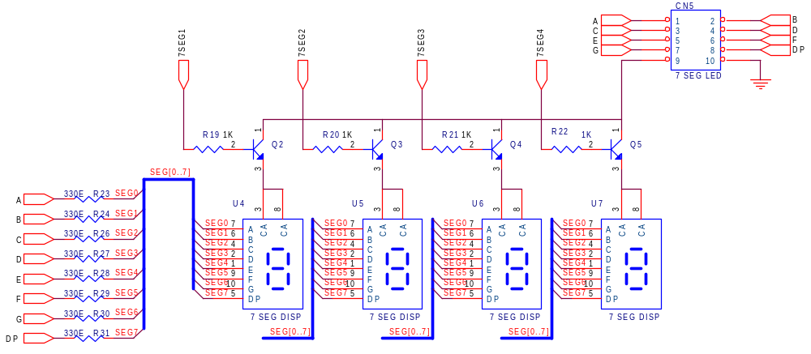

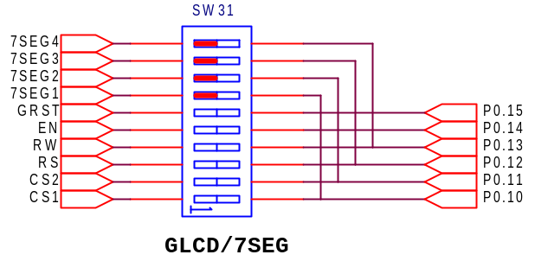
Note : SW31, Make switch settings like above.

6.9 - Interrupts

Microcontroller’s two external interrupts lines are terminated at switches SW5 (EXINT1) and SW6 (EXINT2).

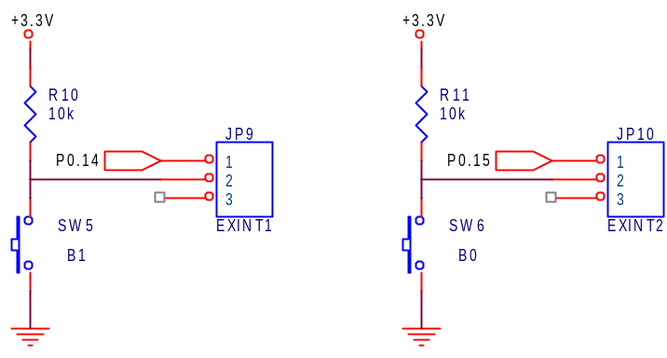

Note: While using interrupt short pin 1&2 at JP9(EXINT1) and 1&2 for JP10(EXINt2)

6.10 - DS1820 Digital Thermometer

- The DS1820 digital thermometer is well suited to environmental temperature measurement, having a temperature range of –55C to 125C and an accuracy of +/-0.5C.
- DS1820 connected to Port P0.26 or P0.29, user can use any of these.

Features
- Unique 1-Wire interface requires only one port pin for communication
- Multi-drop capability simplifies distributed temperature sensing applications
- Can be powered from data line. Power supply range is 3.0V to 5.5V
- Measures temperatures from -55°C to +125°C (-67°F to +257°F)
- ±0.5°C accuracy from -10°C to +85°C
- 9-bit thermometer resolution, Converts temperature in 750ms (max.)

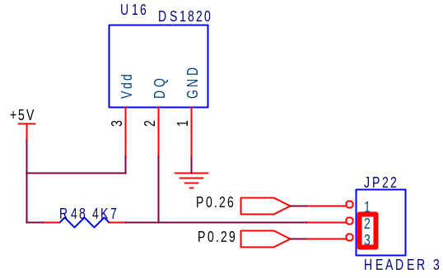

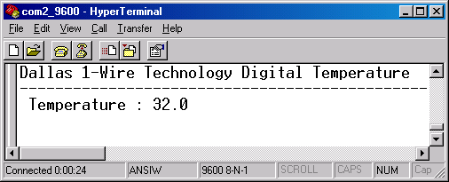

6.11 - 4x4 Matrix keypad

Keypads arranged by matrix format, each row and column section pulled by high or
low by selection J2, all row and column lines terminated at CN3.

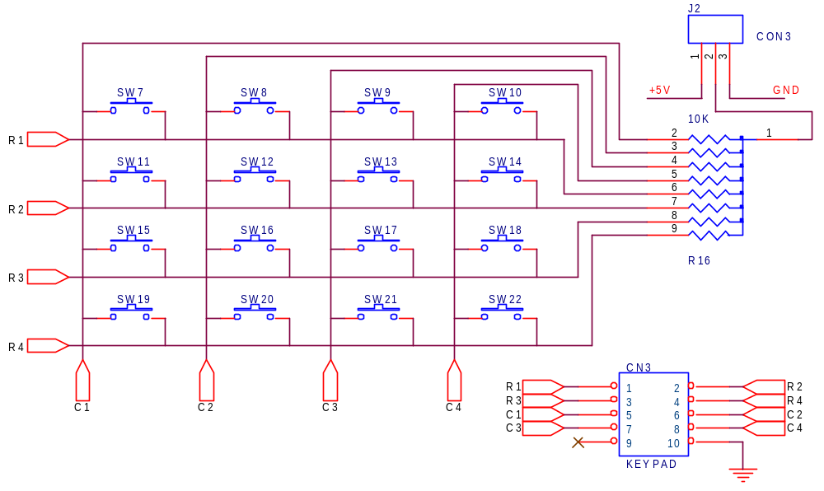

6.12 - Motor / Driver Section

The ULN2803A is a high-voltage, high-current Darlington transistor array. The device consists of eight npn Darlington pairs that feature high-voltage outputs with common-cathode clamp diodes for switching inductive loads. The collector-current rating of each Darlington pair is 500 mA. The Darlington pairs may be connected in parallel for higher current capability.

ULN2803 is used as a driver for port I/O lines, drivers output connected to relay and stepper motor, user can give external supply J7PTB connector. Stepper Motor can connect JP17 or J6 connector.

Note : Select VCC, Internal or External through JP20 header.

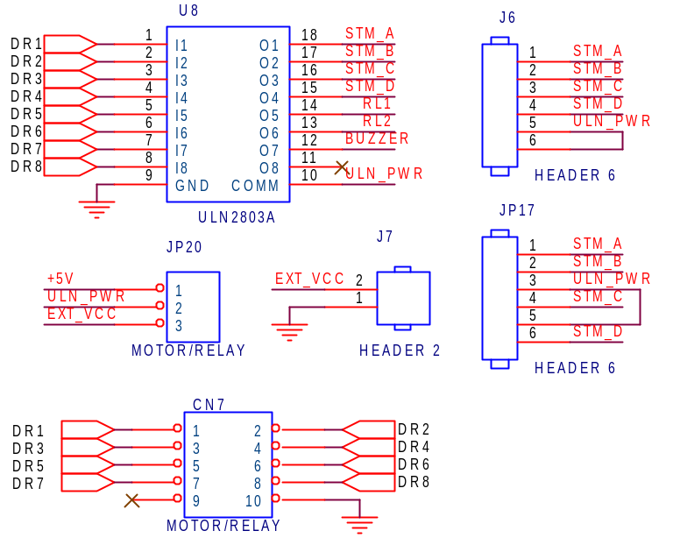

6.13 - Relay & Buzzer Section

In ADB Board two no. Of SPDT relays and one continuous buzzer are used. Both the relays operate on 5V DC. The outputs of both the terminals of the relay are taken out on the connecter to connect the external circuitry. The relay can be connected to the Microcontroller through any of the selected port (P0.4 & P0.5) or (P1.4 & P1.5) or (P2.4 & P2.5) by using the FRC connecter.

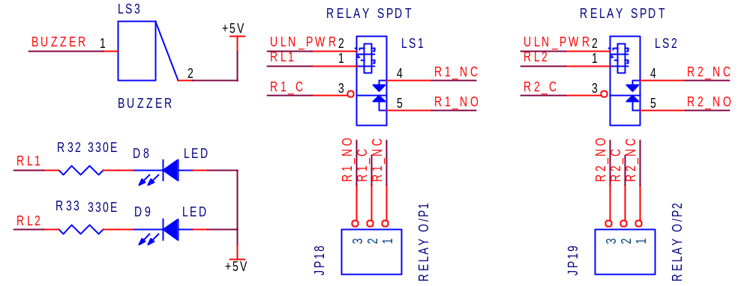

6.14 - SPI DAC

The Microchip Technology Inc. MCP492X are 2.7 – 5.5V, low-power, low DNL, 12-Bit Digital-to-Analog Converters (DACs) with optional 2x buffered output and SPI interface.

The MCP492X are DACs that provide high accuracy and low noise performance for industrial applications where calibration or compensation of signals (such as temperature, pressure and humidity) are required. The MCP492X are available in the extended temperature range and PDIP, SOIC, MSOP and TSSOP packages.

Features
• 12-Bit Resolution
• ±0.2 LSB DNL (typ), ±2 LSB INL (typ)
• Single or Dual Channel
• SPI™ Interface with 20 MHz Clock Support
• Simultaneous Latching of the Dual DACs w/LDAC
• Fast Settling Time of 4.5 μs
• Selectable Unity or 2x Gain Output
• 450 kHz Multiplier Mode
• External VREF Input
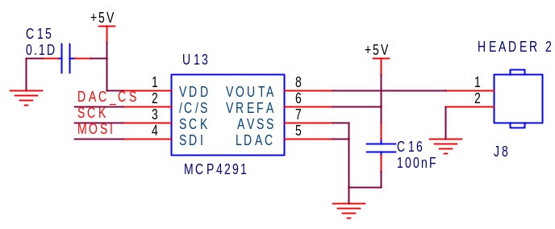
Note : Make switch settings SW33 & SW34 like below
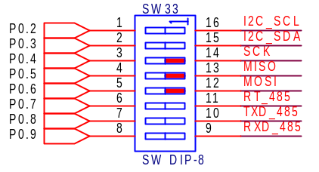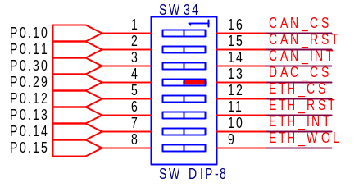

6.15 - RS485

The Max485 is a differential line transceiver suitable for high speed bidirectional data communication on multipoint bus transmission lines. It is designed for balanced data transmission and complies with EIA Standards RS-485 and RS-422. The part contains a differential line driver and a differential line receiver. Both the driver and the receiver may be enabled independently.

Features
- Meets EIA RS-485 Standard
- 5 Mbps Data Rate
- Single 5 V Supply
- –7 V to +12 V Bus Common-Mode Range
- High Speed, Low Power BiCMOS
- Thermal Shutdown Protection
- Short-Circuit Protection
- Driver Propagation Delay: 10 ns
- Receiver Propagation Delay: 15 ns
- High Z Outputs with Power Off

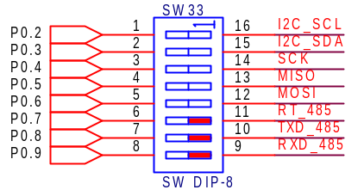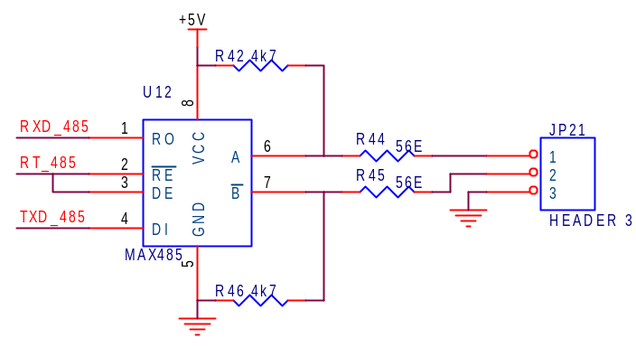

Application Schematic

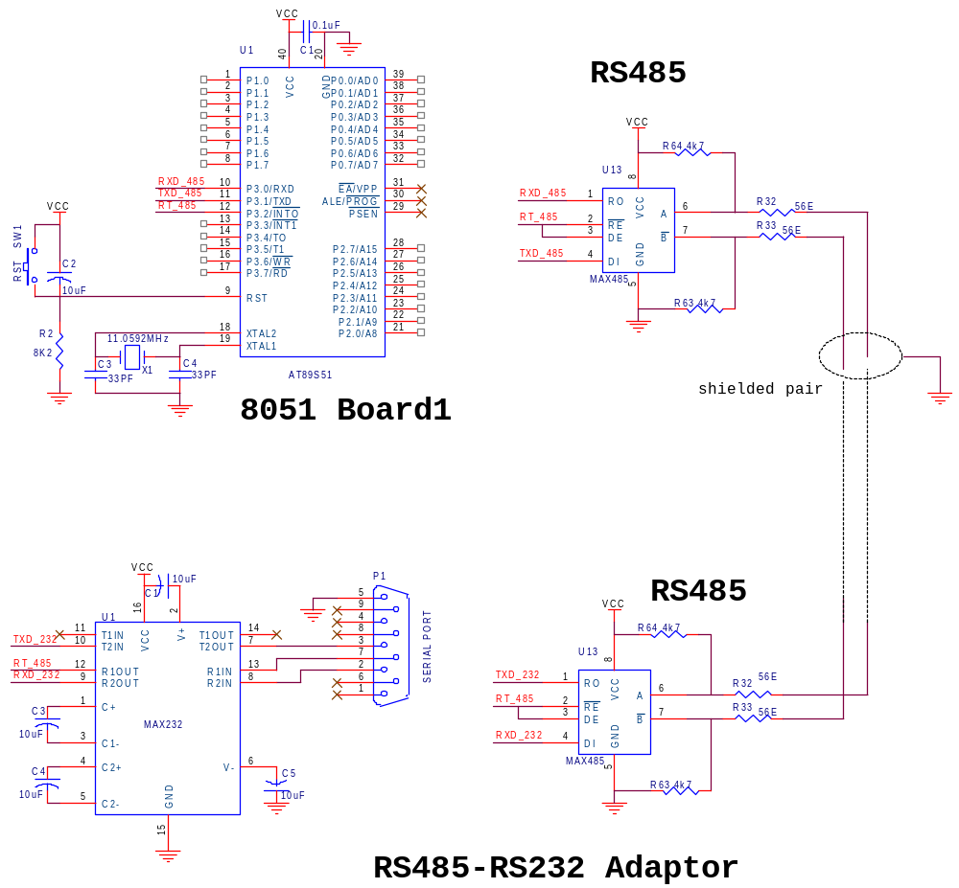

Exemple Code

\Examples Code\RS485\send\out\send.hex
\Examples Code\RS485\receive\out\receive.hex

6.16 - PS/2 Interface

User can connect PS/2 Devices like keyboard, mouse to the 8051 ADB board. PS/2’s DATA(P2.1) and CLK(P2.0) lines connected to MCU’s Port Lines. for example keyboard connected to the ADB board it act as a pc keyboard, pressed key code displayed in LCD or PC’s Hyper terminal window.

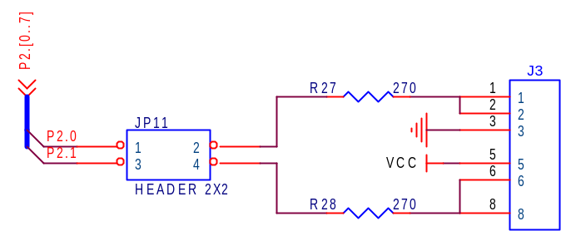

6.17 – Ethernet

The ENC28J60 is a stand-alone Ethernet controller with an industry standard Serial Peripheral Interface (SPI™). It is designed to serve as an Ethernet network interface for any controller equipped with SPI.

The ENC28J60 meets all of the IEEE 802.3 specifications. It incorporates a number of packet filtering schemes to limit incoming packets. It also provides an internal DMA module for fast data throughput and hardware assisted IP checksum calculations. Communication with the host controller is implemented via two interrupt pins and the SPI, with data rates of up to 10 Mb/s. Two dedicated pins are used for LED link and network activity indication.

Ethernet Controller Features
IEEE 802.3 compatible Ethernet controller
• Integrated MAC and 10BASE-T PHY
• Receiver and collision squelch circuit
• Supports one 10BASE-T port with automatic polarity detection and correction
• Supports Full and Half-Duplex modes
• Programmable automatic retransmit on collision
• Programmable padding and CRC generation
• Programmable automatic rejection of erroneous packets
• SPI™ Interface with speeds up to 10 Mb/s

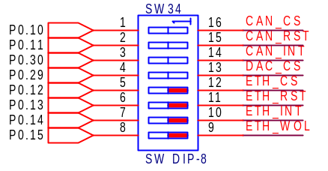

RJ-45 In-built Transformer
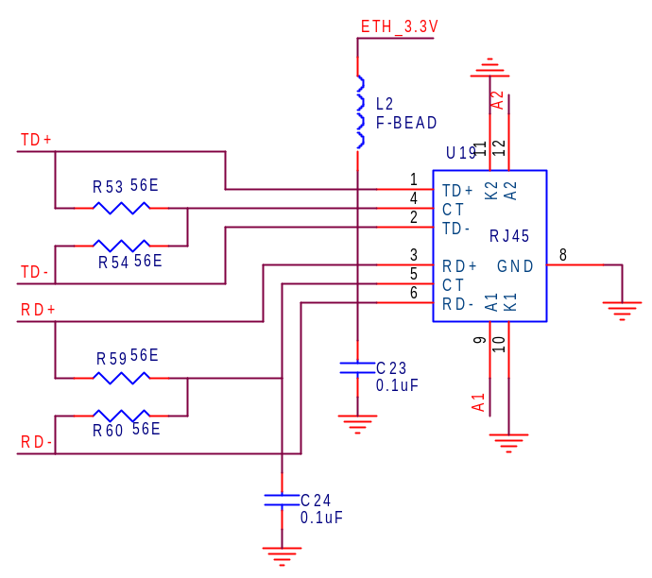

Driver Section
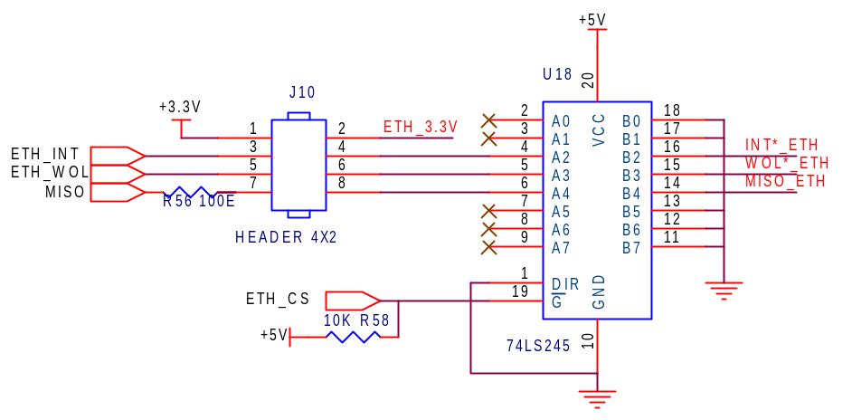

ENC28J60 Section

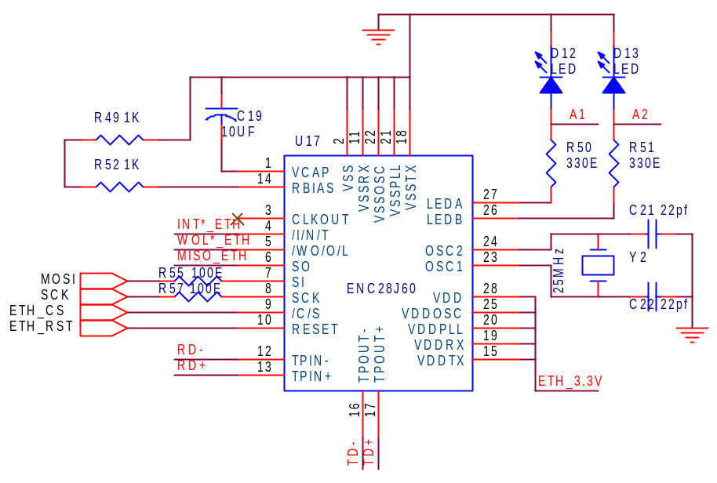

7. Board Layout

Easy Programming Steps

